Association of Professional Party Organizers
&
Event Managers of Nigeria

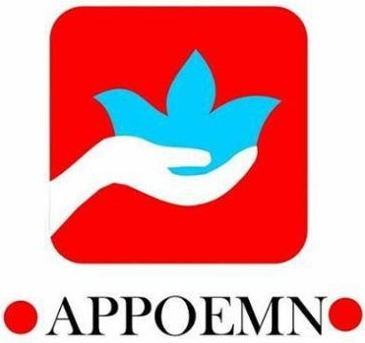

MENTORING PROGRAM
Mentee’s Application Form
6 months Appoemn mentoring program on 15th May, 2019 – 31st October, 2019
Date of Application _____\______\_______
CONTACT INFORMATION
Name: ________________________________________________________
Address: ______________________________________________________
State of Origin: _________________________________________________
Gender: Male ( ) Female ( )
Phone number: _________________________________________________
Email: _________________________________________________________
Website: _______________________________________________________
EDUCATIONAL BACKGROUND
University / Institute: College: ______________________________________
Additional Qualifications with dates: _________________________________
EMPLOYMENT INFORMATION
Company/ Organization/ Faculty: ___________________________________
Position: _______________________________________________________
How long have you been in business: ________________________________
What are your expectations for the 6 months mentoring _______________________________________________________________
Location: _______________________________ Signature: ______________

